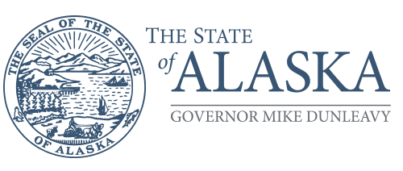
Department of Administration

OFFICE OF PROCUREMENT & PROPERTY MANAGEMENT

333 Willoughby Ave, Suite 801
Juneau, Alaska 99801
Main: 907.465.2250
Fax: 907.465.2189

October 20, 2021
MEMORANDUM

From: ____________________________
Title: ____________________________
Department: ____________________________

To: Thor Vue
Chief Procurement Officer
OPPM, Department of Administration

Thru: OPPM Policy and Oversight Section
Mindy Birk, Chief of Policy
OPPM, Department of Administration

Subject: Procurement Violation Report

This procurement violation report is being submitted on __________________, by the Department of _________________________, in accordance with AAM 82.330.

Description of Procurement Violation

Procurement Officer’s Investigation Findings:

Procurement Officer’s Conclusions and Recommendations for Corrective Action:

