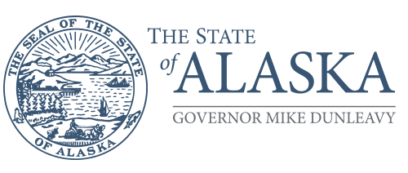

Department of Name

DIVISION NAME

Address
Phone

Memorandum

To: Thor Vue Date:
Chief Procurement Officer
Department of Administration
Office of Procurement and Property Management

From: Name Subject: Choose an item.
Title
Department of Name
Division Name

Solicitation Title: Title

Solicitation Number: Number

Required by Date: Date

Provide the appropriate information below (and delete this text and all the instructions below) and email to DOA.OPPM.PolicyOversight@alaska.gov

Cost Waiver Instructions: Provide a description of the solicitation and per AAM 81.470(3), explain in detail why it is not in the State’s best interest to use minimum percentage for price evaluation (40% for services contracts and 60% for supply contracts) and why that minimum will prevent the agency from accomplishing its public mission. It may be helpful to identify the other evaluation criteria, where you plan to assign the other points, and why that is important.

Foreign Outsourcing Waiver Instructions: Provide a description of the solicitation and per AAM 81.015, explain in detail why it is in State’s best interest to allow the services to be performed outside the United States, and why limiting competition to service providers located in the United States could damage the agency’s ability to accomplish its public mission. A discussion of cost may be included if that is a determining factor in accomplishing the agency’s public mission.

Important Note: The Office of Information Technology, Security Policy 112, requires review and approval from the State Security Office (SSO) prior to “conducting business with vendors, contractors, business partners, and other third-party entities with authorized access to SOA information and information assets operating within or on behalf of the SOA.” When requesting a foreign outsourcing waiver, if the vendor may also have access to SOA information and information assets operating within or on behalf of the SOA or may have SOA data stored outside the United States, the SSO approval must be attached with your waiver.

Out of State Solicitation Waiver Instructions: Provide a description of the solicitation and why it’s in the State’s best interest to allow soliciting vendors outside Alaska. Reference AAM 81.090

Cooperative Purchasing Agreement (Multi-Agency): Provide a description of why it’s in the State’s best interest to allow two or more agencies to enter into a cooperative agreement for the purpose of contracting jointly with a private sector entity. Reference AAM 81.060

☐ Approve ☐ Deny

Thor Vue Date
Chief Procurement Officer
Department of Administration
Office of Procurement and Property Management

